**LESSON 8: PROCESSORS**

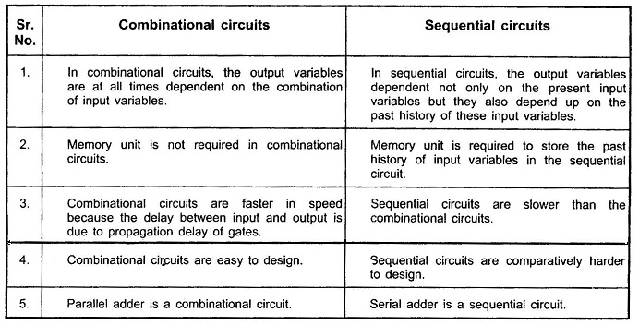

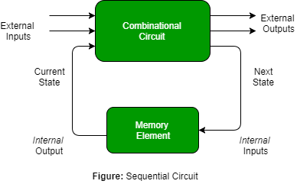

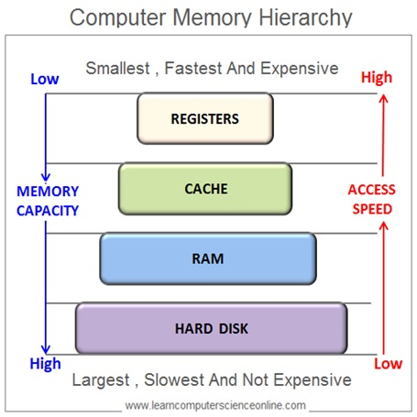

COMPUTER SYSTEM PARTS

* PROCESSOR is the central unit in a computer system that performs computations and executes instructions from programs. It is often referred to as the **Central Processing Unit (CPU)** and is responsible for tasks like arithmetic operations, decision-making, and managing data flow between components.
* MEMORY refers to a system's data storage components that temporarily or permanently hold data and instructions for processing.
* I / O DEVICES **devices** are hardware components that allow interaction between a computer and its environment.
* BUS is a communication system that transfers data between computer components or devices.
* THROUGHPUT is the amount of data successfully processed or transmitted by a system in a given period, typically measured in units like bits per second (bps) or operations per second. It reflects the efficiency and performance of a system.
* LATENCY is the time delay between a request for data and the start of its delivery. In computing, it often refers to the delay in processing or communication, such as the time taken for a network packet to travel from source to destination.

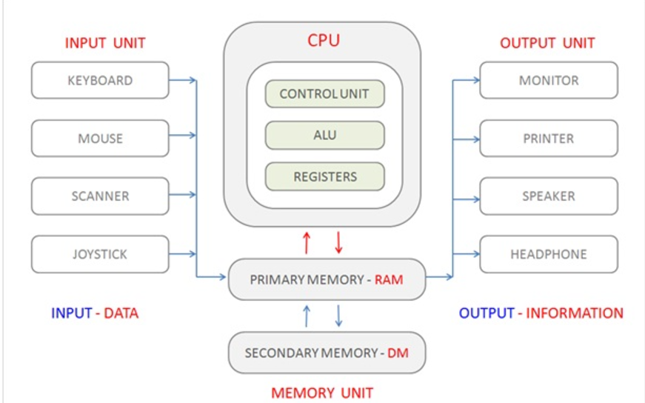

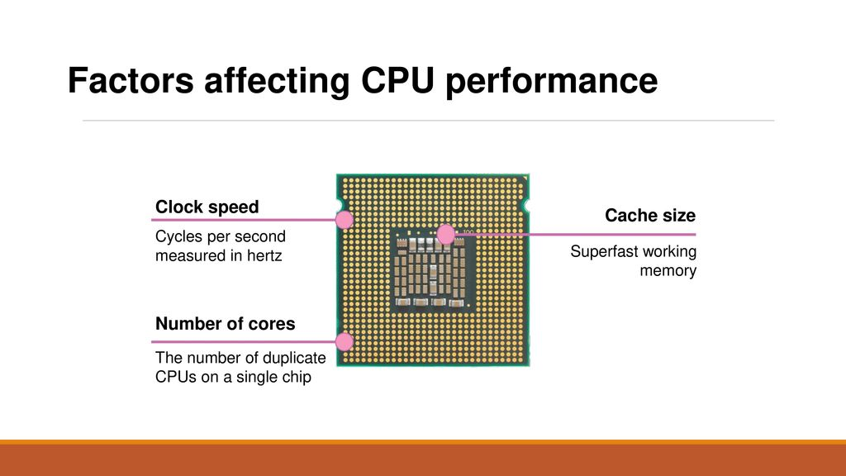

CLOCK SPEED

* Clock speed is how quickly a processor completes tasks. It is measured in **GHz (gigahertz)**, which tells you how many billions of cycles the CPU can perform in one second. Each "cycle" is like a tick of a clock and represents a unit of work the processor can do.
* **Simple Analogy**: Think of it as the speed of a car. A higher clock speed means the CPU can "drive" faster and finish tasks more quickly. However, speed isn’t everything—other factors, like the number of cores, also matter.

CORE

* A **core** is an individual processing unit inside a CPU. Each core can handle its own tasks, meaning that more cores enable a processor to multitask better.
* **Simple Analogy**: Imagine a restaurant kitchen. Each chef (core) can prepare a separate dish, so having more chefs lets you cook more food at the same time.

CACHE

* Cache is a small, super-fast memory built into the CPU. It temporarily stores data and instructions that the processor is likely to use next. This helps the CPU avoid going to the slower main memory (RAM) every time it needs information.
* **Simple Analogy**: Think of it as a notepad the CPU keeps on hand for quick reference instead of repeatedly checking a book (RAM).

HYPERTREADING

* Hyper-Threading is a technology that makes a single core act like **two virtual cores**, allowing it to handle two tasks (or threads) at the same time. This improves multitasking and processing efficiency without adding extra physical cores.
* **Simple Analogy**: Imagine each core is a worker. Hyper-Threading allows each worker to handle two smaller tasks at the same time instead of focusing on just one. This boosts productivity, though it’s not as powerful as having twice as many workers (physical cores).

OVERCLOCKING

* **Overclocking** is the process of increasing a computer component's clock speed (usually the CPU, GPU, or RAM) beyond the manufacturer’s recommended settings. This allows the component to perform more operations per second, resulting in faster performance.
* **Simple Analogy :** Think of overclocking as revving the engine of a car beyond the manufacturer’s suggested limits. You get more speed, but it generates more heat and puts extra strain on the engine.

THERMAL DESIGN POWER (TDP)

* - The **thermal design power** (**TDP**), sometimes called **thermal design point**, is the maximum amount of [heat](https://en.wikipedia.org/wiki/Heat) generated by a computer chip or component (often a [CPU](https://en.wikipedia.org/wiki/CPU), [GPU](https://en.wikipedia.org/wiki/GPU) or [system on a chip](https://en.wikipedia.org/wiki/System_on_a_chip)) that the [cooling system](https://en.wikipedia.org/wiki/Computer_cooling) in a computer is designed to [dissipate](https://en.wikipedia.org/wiki/Dissipation) under any workload.

